Focus : Acquire images from scopy machines.

Acquiring single frame and multi frame images from both DICOM and non-DICOM images from Scopy machines for storage, analysis and distribution.

Key Features :

- Intuitive editing of multiframe(cine loop)
- Template based reporting with images and reports
- Distribution thro’ CD, pendrive
- Image transfer to any PACS

Features :

- Adding Patient Information

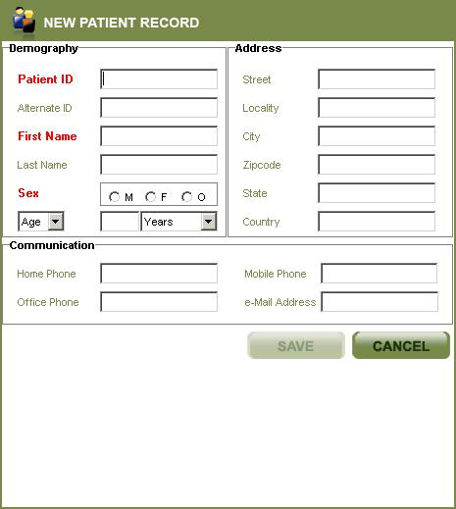

Allows to add patient information thro’ DICOM / Direct Manual entry

- Adding Study
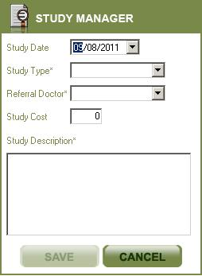
Allows to add study information thro’ DICOM / Direct Manual entry

- Multiple studies
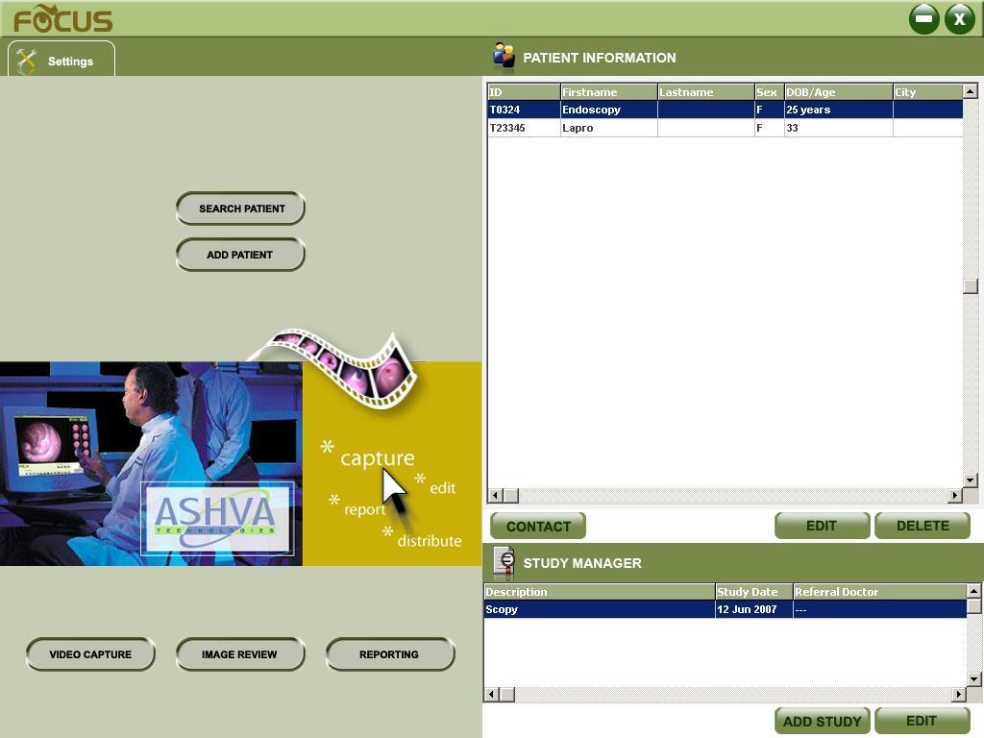
Ability to link multiple studies of a patient

- Image Acquisition

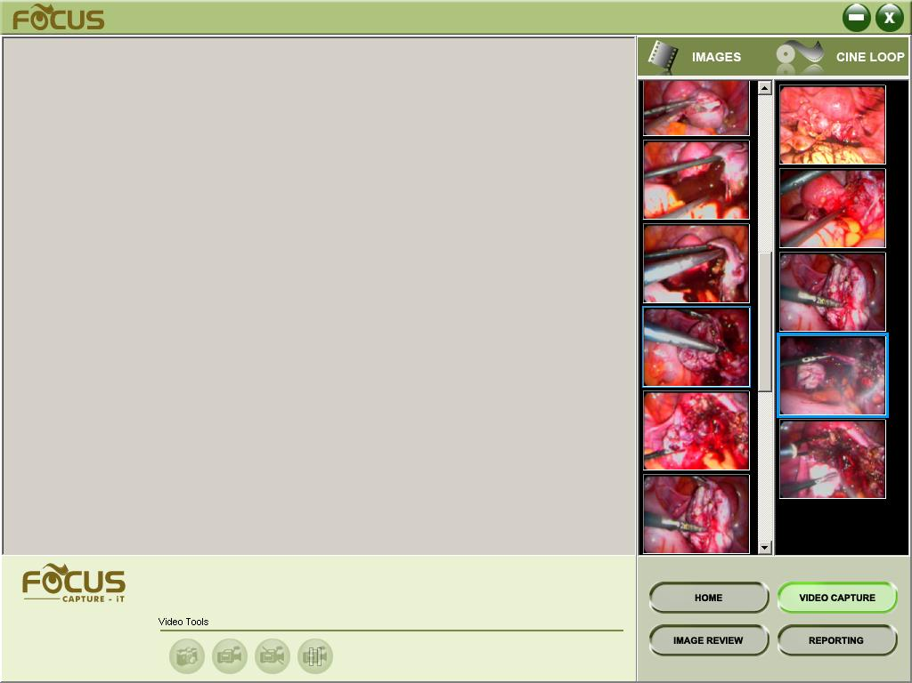

Allows to acquire single frames and sequences from Non-DICOM and DICOM images. Presets and footswitch integration enabled.

- Image Manipulation - Single Frame Images & Cine loops
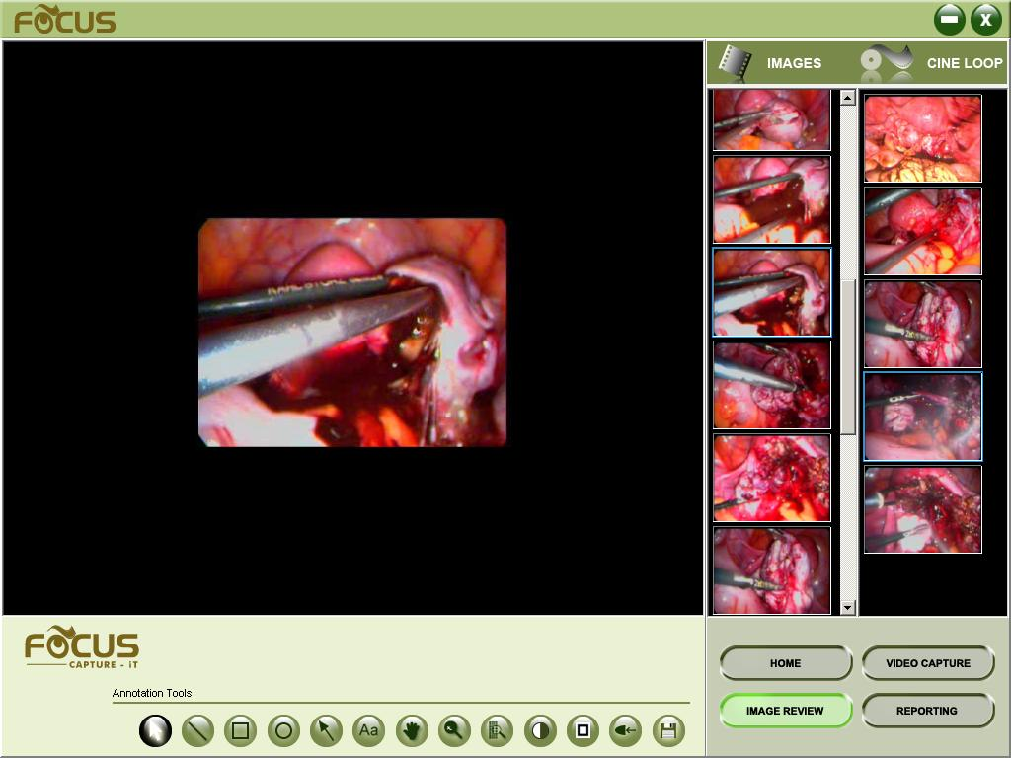
Option to change brightness / contrast, Draw line, circle etc., zoom / pan, foot notes, tagging key images. For Cine loops - option to play & edit sequences, rotate/flitp, export with MPEG compression

- REPORTING
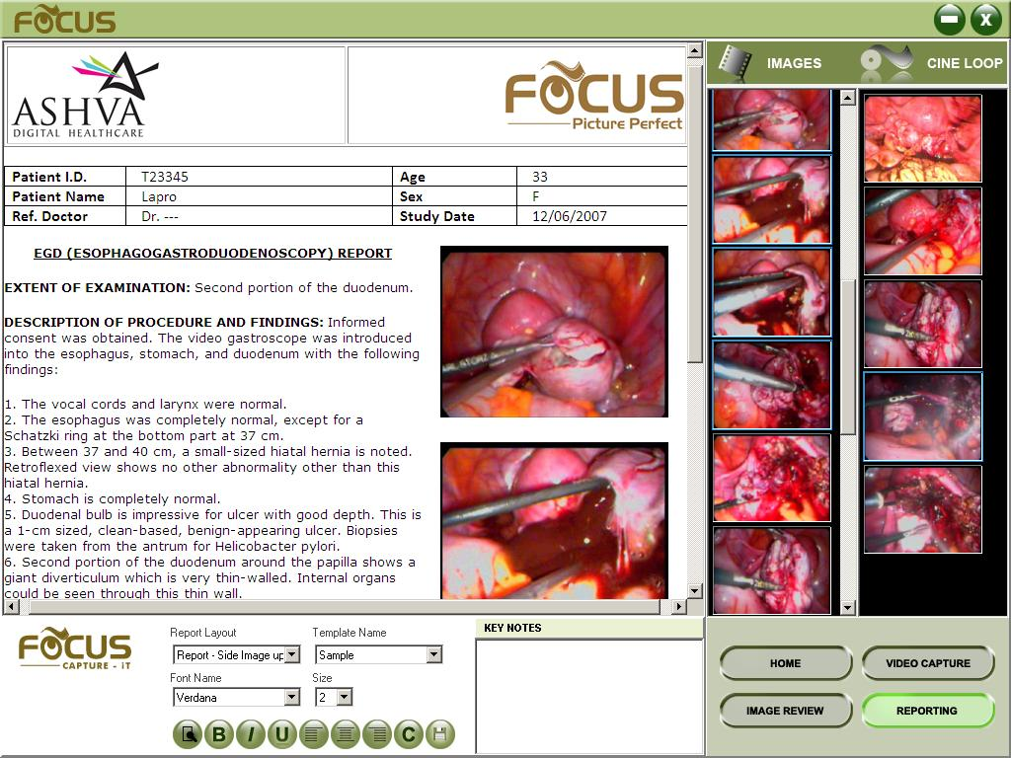

Ability to have multiple report templates for each study, user defined customizable templates, customizable report header, drag and drop images for reporting, important reference images in text layout.

7.Report Distribution

Reports can be written on a CD / saved to Disk / Printed on plain/pre-printed stationary /e-mailed / exported to Power-point. Images can be exported in multiple formats and saved on disk. 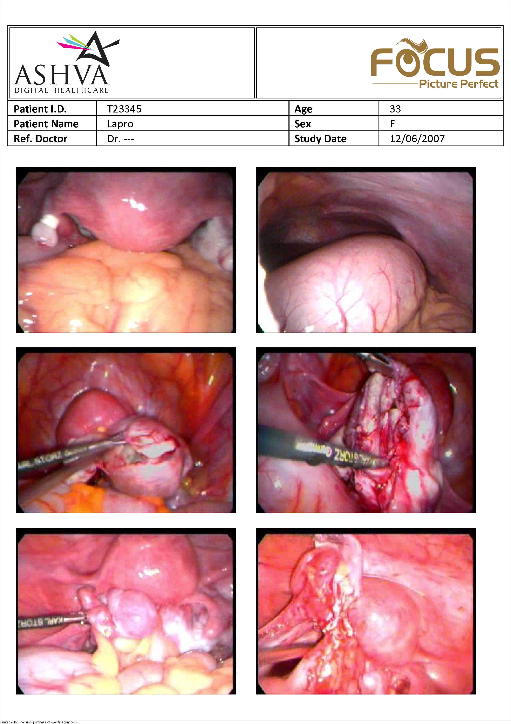

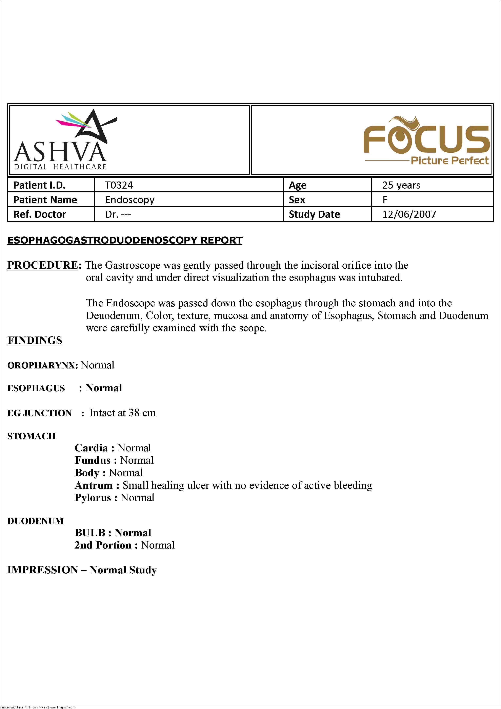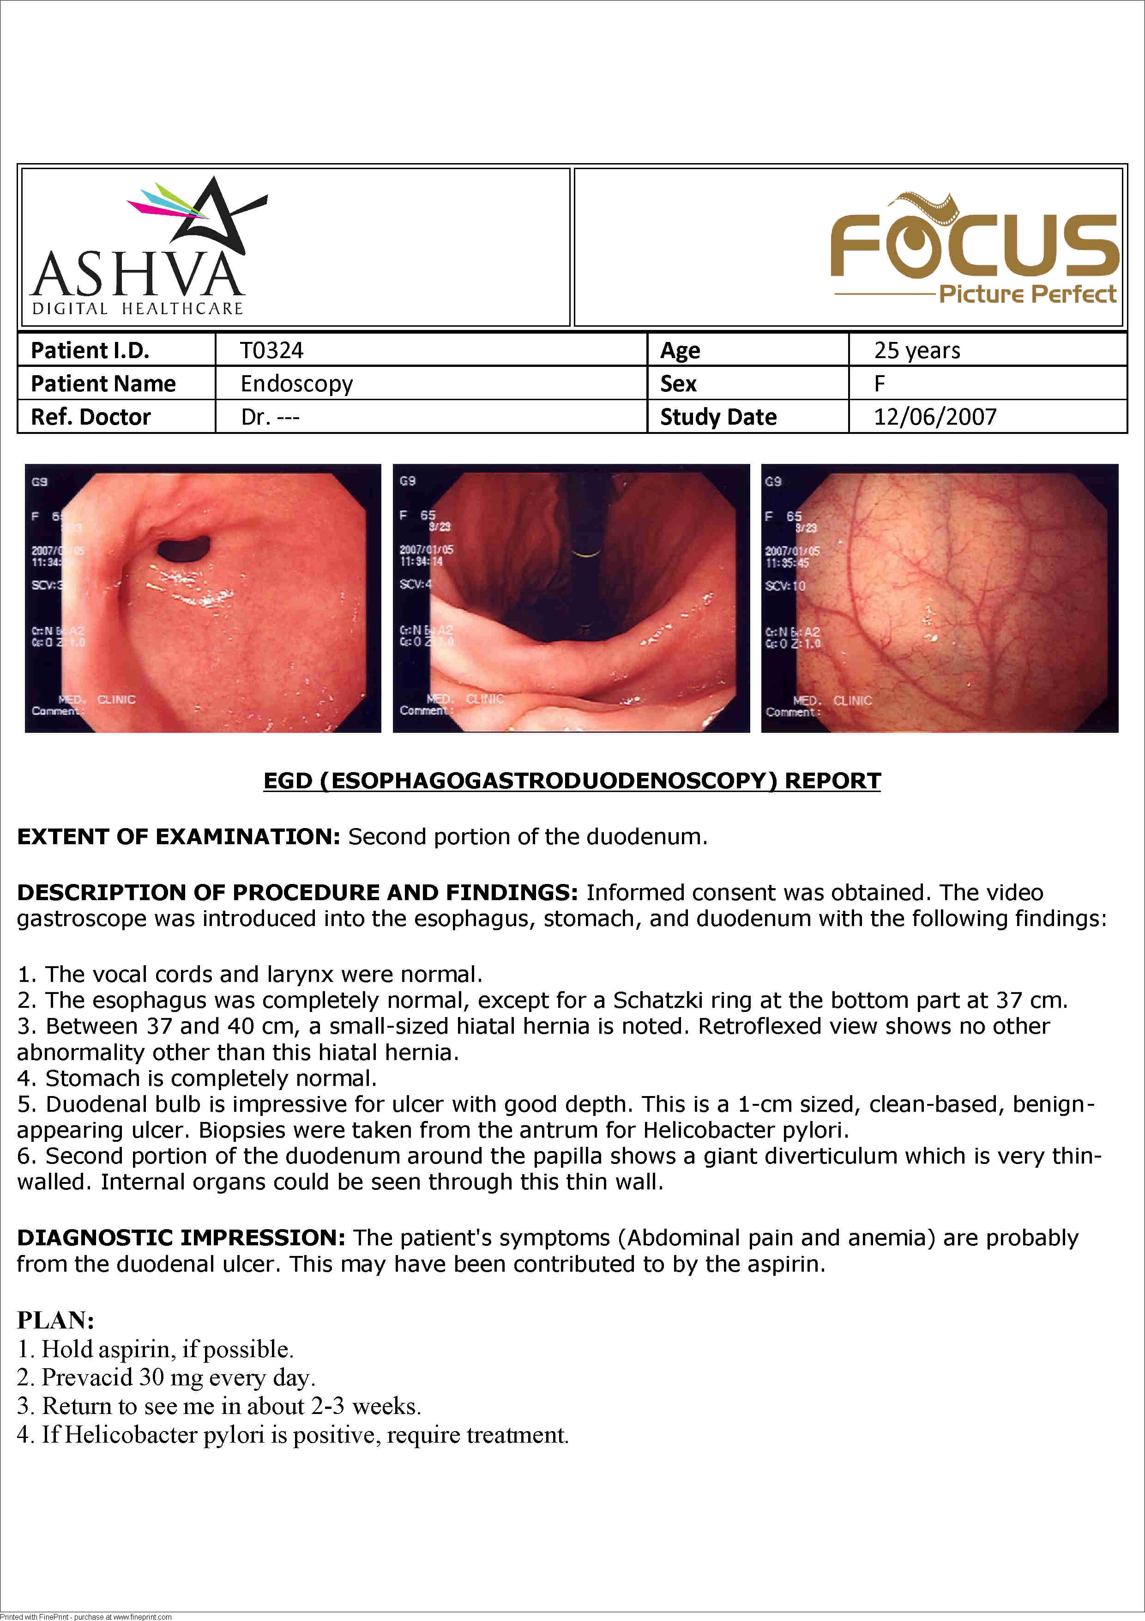

- QUERY Facility

Ability to query based on key image, gender, type, referral doctor, key notes, study date, study type available.

